Name : muhammad usama.

Roll no : 17F_8195.

Section : B.

Lab :3

Task 1:

#include<iostream>

using namespace std;

void incrementptr(int *ptr);

int main()

{

int arry[10]={0};

int* ptr=arry;

cout<<"eneter the 10 elements that you want to increment by 1 "<<endl;

for(int i=0; i<10; i++)

{

cin>>*(ptr+i);

}

incrementptr(ptr);

for(int i=0; i<10; i++)

{

cout<<" "<<*(ptr+i);

}

cout<<endl;

system("pause");

return 0;

}

void incrementptr(int *ptr)

{

for(int i=0; i<10; i++)

{

*(ptr+i)=*(ptr+i)+1;

}

}

Result:

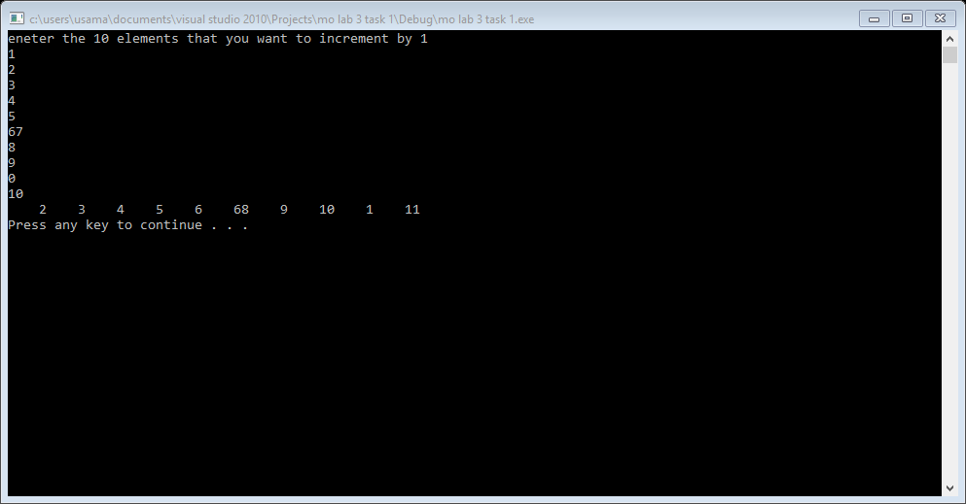

Task 2 :

#include<iostream>

using namespace std;

void print(void* ptr);

int main()

{

int arr[10]={1,2,3,4,5,6,7,8,9};

void* ptr=arr;

print(ptr);

system("pause");

return 0;

}

void print(void* ptr)

{

for(int i=0; i<10; i++)

{

cout<<*((int*)ptr+i)<<" ";

}

}

Result:

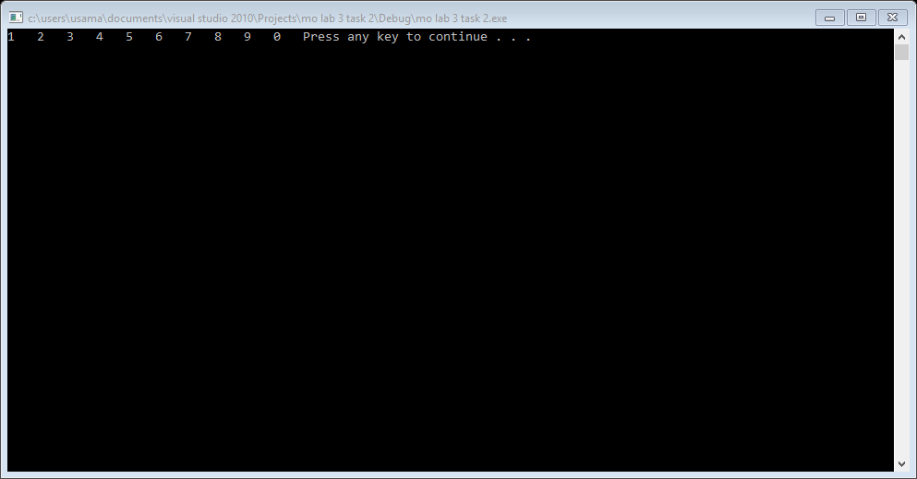

Task 3:

#include<iostream>

using namespace std;

void print(int* ptr,int index);

int main()

{

int arr[10]={1,2,3,4,5,6,7,8,9};

int* ptr=arr;

int index=0;

cout<<"enetr the index that you want to print : ";

cin>>index;

print(ptr,index);

system("pause");

return 0;

}

void print(int* ptr,int index)

{

cout<<index<<" index have value is : "<<*(ptr+index+1)<<endl;

}

Result:

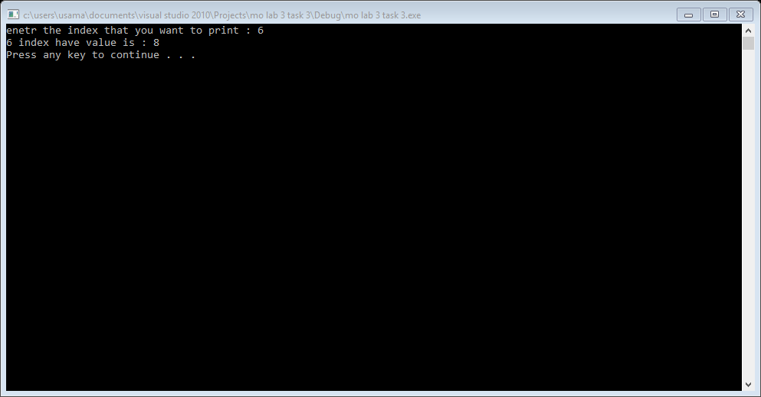

Task 4:

#include<iostream>

using namespace std;

void print(int*const ptr,int index);

int main()

{

int arr[10]={1,2,3,4,5,6,7,8,9};

int* const ptr=arr;

int index=0;

cout<<"enetr the index that you want to print : ";

cin>>index;

print(ptr,index);

system("pause");

return 0;

}

void print(int*const ptr,int index)

{

cout<<index<<" index have value is : "<<*(ptr+index)<<endl;

}

Result:

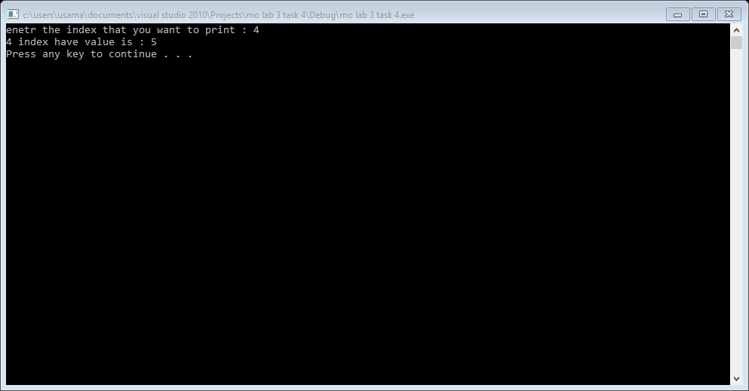

Task 5:

#include<iostream>

using namespace std;

void bibblesort(char* ptr,int size);

int main()

{

int size;

char arry[30]={'b','c','d','e','g','a','f','l','m','o','h','j','i','x','z','y','s','t','u','v','w','k','n','p','q'};

char* ptr=arry;

cout<<"enetr the size of arry : "<<endl;

cin>>size;

bibblesort(ptr,size);

for(int i=0; i<size; i++)

{

cout<<*(ptr+i)<<" ";

}

cout<<endl;

system("pause");

return 0;

}

void bibblesort(char* ptr,int size)

{

cout<<"this soerting is done by bubble sort"<<endl;

int temp=0;

for(int iter=1; iter<size; iter++)

{

for(int i=0; i<size-iter; i++)

{

if(*(ptr+i)>*(ptr+(i+1)))

{

temp=*(ptr+(i+1));

*(ptr+(i+1))=*(ptr+i);

*(ptr+i)=temp;

}

}

}

}

Result:

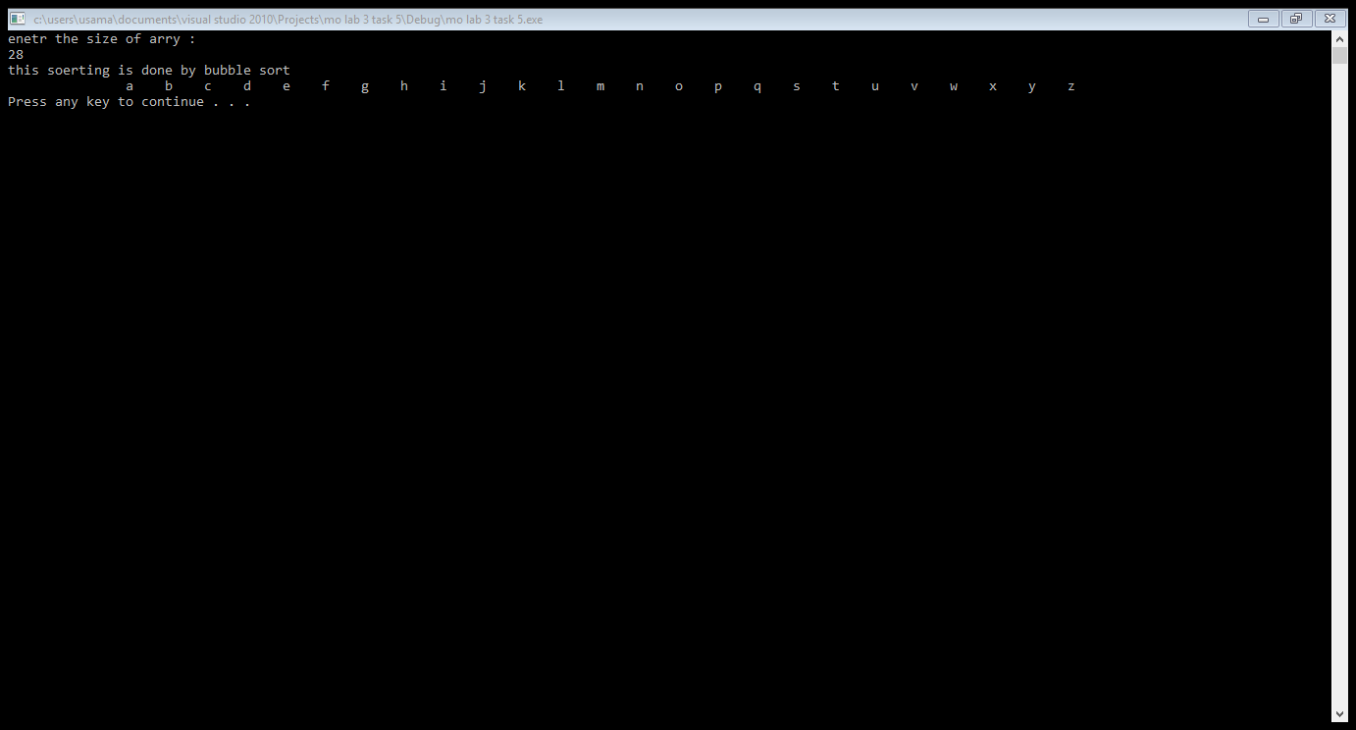

Task 6:

#include<iostream>

using namespace std;

int fun(int *ptr,int& x);

int main()

{

int x=10;

int y=0;

int *ptr=&x;

if(fun(ptr,x)==true)

{

cout<<"adress of variable and pointer is same"<<endl;

}

else

{

cout<<"adress of variable pointer is not same"<<endl;

}

system("pause");

return 0;

}

int fun(int *ptr,int &x)

{

if(ptr==&x)

{

return true;

}

else

{

return false;

}

}

Result:

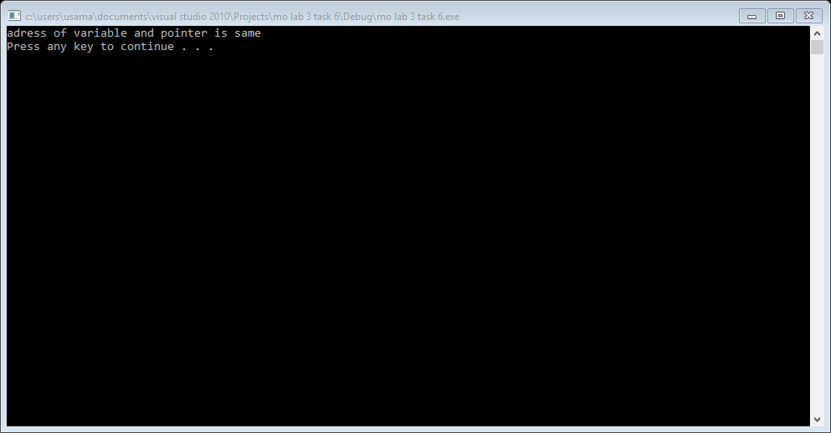

Task 7:

#include<iostream>

using namespace std;

void selectionsort(int *ptr,int size);

int main()

{

int arry[1000]={0};

int *ptr=arry;

int size;

cout<<"enetr the size of arry"<<endl;

cin>>size;

for(int i=0; i<size; i++)

{

cout<<"enetr "<<i+1<<" element of arry : ";

cin>>*(ptr+i);

}

selectionsort(ptr,size);

cout<<"sorted elements is "<<endl;

for(int i=0; i<size; i++)

{

cout<<" "<<*(ptr+i);

}

cout<<endl;

system("pause");

return 0;

}

void selectionsort(int *ptr,int size)

{

cout<<"this soerting is done by selection sort"<<endl;

int i=0,smalli=0,temp=0;

for(i=0; i<size; i++)

{

smalli=i;

for(int j=i; j<size; j++)

{

if(*(ptr+j)<*(ptr+smalli))

{

smalli=j;

}

}

temp=*(ptr+smalli);

*(ptr+smalli)=*(ptr+i);

*(ptr+i)=temp;

}

}

Result:

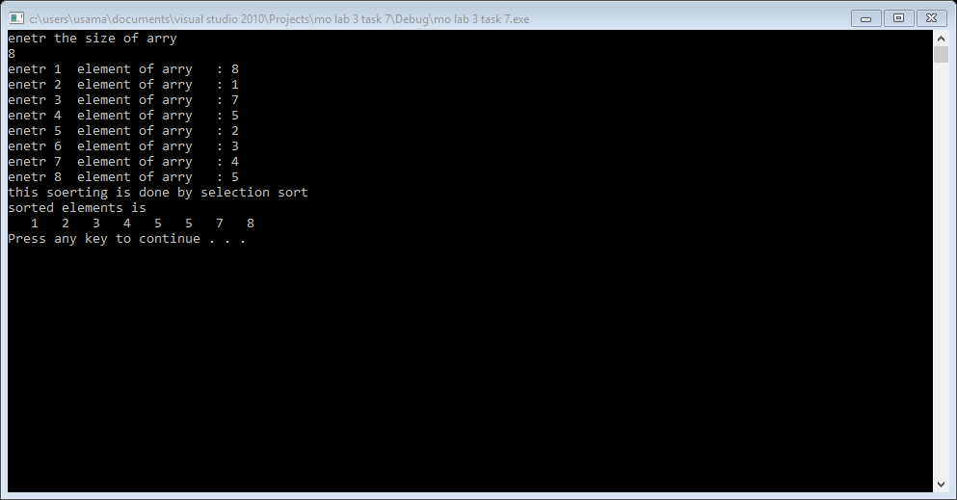

Task 8:

#include<iostream>

using namespace std;

void fun(char *ptr,int size);

int main()

{

char arry[1000]={0};

char *ptr=arry;

int size=0;

fun(ptr,size);

system("pause");

return 0;

}

void fun(char *ptr,int size)

{

cout<<"enter the size of arry"<<endl;

cin>>size;

for(int i=0; i<size; i++)

{

cout<<"enetr "<<i+1<<" element of arry : ";

cin>>*(ptr+i);

}

for(int i=0; i<size; i++)

{

cout<<i+1<<" element that you enter is : "<<*(ptr+i);

cout<<endl;

}

}

Result:

